***C:\Users\Jelena\Desktop\logo mtv.jpgC:\Users\Jelena\Desktop\index.jpg***

***LOCAL ROADS CONNECTIVITY PROJECT***

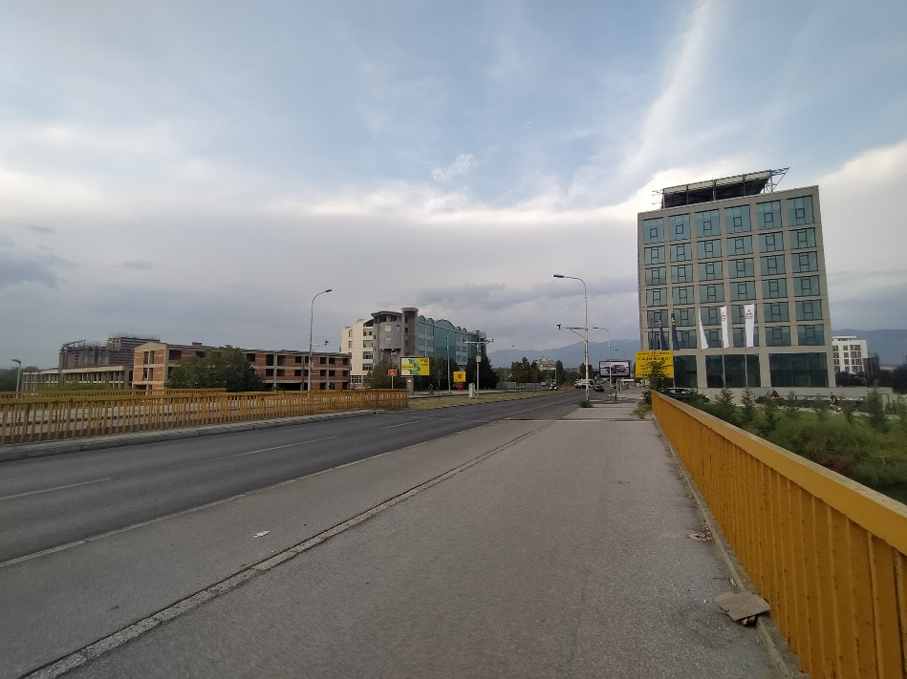

October, 2020

**ENVIRONMENTAL AND SOCIAL MANAGEMENT PLAN (ESMP)**

*for the project*

*Reconstruction of Blvd. Kiro Gligorov, from the Bridge “Bliznak”*

*to the overpass on Blvd. Aleksandar Makedonski” in Municipality of Gazi Baba, in City of Skopje*

Prepared by:

Slavjanka Pejchinovska-Andonova, MSc, Environmental Engineer

Environmental and Social (E&S) Specialist

Contents

1. INTRODUCTION 1

2. PROJECT DESCRIPTION 2

2.1 Baseline condition of Municipality of Gazi Baba 2

2.1.1 Demography 2

2.1.2 Climate features 3

2.1.3 Seismology 4

2.1.4 Water 4

2.1.5 Air quality 4

2.1.6 Waste 4

2.1.7 Geology and soil 5

2.1.8 Flora and fauna 5

2.1.9 Noise 7

2.1.10 Cultural heritage 7

2.2 Project location 7

2.3 Project Activities 11

2.4 Sensitive receptors 11

3. POTENTIAL ENVIRONMENTAL IMPACT AND RISK AND IMPACT AND RISK ASSESSMENT 12

4. ENVIRONMENTAL AND SOCIAL MITIGATION PLAN 18

5. ENVIRONMENTAL AND SOCIAL MONITORING PLAN 21

6. ANNEX 24

**IMAGES**

Figure 1 Location of the project area in relation with the Municipality of Gazi Baba 2

Figure 2 Map with potential natural hazards (erosion, floods, landslides and earthquakes) in RNM 3

Figure 3 Part of the vegetation in protected area “Ostrovo” 5

Figure 4 Part of the Arboretum, which is part of the protected area “Ostrovo” 6

Figure 5 Part of Ezerce, which is part of the protected area “Ostrovo” 7

Figure 6 Tumba – archeological site 7

Figure 7 Macrolocation of the project site in Municipality Gazi Baba 8

Figure 8 Micolocation of project site in Municipality of Gazi Baba 8

Figure 9 Current situation of the project area Municipality of Gazi Baba 11

**TABLES**

Table 1 Planned project activities in Municipality of Gazi Baba 11

Table 2 Possible environmental impacts and risks 12

Table 3 COVID-19 considerations in construction/civil works projects recommended by WB 25

ABBREVIATIONS

|  |  |
| --- | --- |
| EIA | Environmental Impact Assessment |
| ESMF | Environmental and Social Management Framework |
| ESMP | Environmental and Social Management Plan |
| LRCP | Local Road Connectivity Project |
| MoEPP | Ministry of Environment and Physical Planning |
| MSC | Macro seismic |
| MTC | Ministry of Transport and Communications |
| MN | Monument of Nature |
| OH&S | Occupational Health and Safety |
| PCE | Public Communal Enterprise |
| PIU | Project Implementation Unit |
| RM | Republic of Macedonia |
| RNM | Republic of North Macedonia |

# INTRODUCTION

Within the Republic of North Macedonia, the current situation of transport sector indicates with poor condition of the local roads network, unsatisfactory level of financing of road maintenance, weakness of international investment in distribution sector and transport sector etc. Such poor condition of the local roads is as a result of lack of financial capacity of the Local Self Government that differs from region to region in the country. Some of the local roads in the rural areas are in an unacceptable condition with no access to the hospitals, schools and markets so this issue brings social problems as well.

Through the Local Roads Connectivity Project (LRCP), the Ministry of transport and communications will implement 70 million Euro investment secured by the World Bank, in order to support the municipalities in the country, mostly in rehabilitation of existing local road infrastructure (urban / rural streets, regional and local roads), reconstruction, rehabilitation, upgrading, pedestrian paths, street lightening, water drainage and capacity building of the municipal staff.

When preparing these type of projects, according to the national environmental requirements (Law on Environment and secondary legislation), it is necessary to submit a Notification Letter for intention to start the project to the MoEPP which initiates the environmental impact assessment procedure and based on the Opinion, to prepare the EIA Report.

The prepared EIA Report is in accordance with Article 24 of the Law on Environment (Official Gazette of the Republic of Macedonia No 53/05, 81/05, 24/07, 159/08, 83/09, 48/10, 124/10, 51/11, 123/12, 93/13, 187/13, 42/14, 44/15, 129/15, 192/15, 39/16 and 98/18) and the Rulebook on the Form and Contents of the EIA Report in accordance with the types of activities for which the report is being prepared, as well as in accordance with the entities performing the activity and the scope of activities being performed by the legal and natural entities, the procedure for their approval, as well as the method for keeping of the register of approved reports (Official Gazette of the Republic of Macedonia No 44/13, 111/14).

The projects that cover upgrading and rehabilitation of roads belong to the chapter X – Infrastructure projects, item 1 Upgrading of local roads, defined in the secondary legislation and for these projects an EIA Report should be prepared.

The Municipality of Gazi Baba will prepared an EIA Report and sent a copy together with the Decision for its approval to the MoTC, with other technical documents.

In September/October 2019Environmental and Social Management Framework (ESMF) was prepared for the whole LRCP project, in order to address Project’s potential environmental and social concerns in accordance with the requirements of the World Bank Assessment and Management of Environmental and Social Standards. ESMF is used as a basis for the creation of site specific Environmental and Social Management Plans (ESMP) and ESMP Checklists which will address in detail environmental and social aspects of sub-projects identified in the course of project preparation and implementation.

Within territory of Municipality of Gazi Baba (part of City of Skopje), the planned project activities, will be implemented one of the most frequent traffic roads within the capital city of RNM – Blvd. Kiro Gligorov. The route of the project site starts from bridge “Bliznak” and ends as a junction to the overpass on Blvd. Aleksandar Makedonski, in total length of 730.12 m and width of 14m (2x7 m). The road surface is in relative good condition, but cracks and damages are evident as result of the frequent and heavy vehicles movements at this street/boulevard. Along the project site, mostly industrial/commercial facilities are located. At the beginning of the route of the street/boulevard river Vardar and FON University are located. In the close surrounding of the project site, residential facilities, church, accommodation facility, recreation park, etc. are located. In the wider surrounding of the project site are located following: protected area “Ostrovo” (about 3.2 km southeast from the project site); forest park “Gazi Baba” (about 1.1 km west from the project site); private hospital “Re-Medika” (about 1.3 km northwest from the project site); etc.

The main activities will include: marking and securing the route at the project location; putting up security and alert signalization along the route of the project area; asphalt scraping and clearing of the scrapped areas; extraction of cobblestone; putting on buffer layer; coating of the scrapped areas and buffer layer with bitumen emulsion; placing a bearing bitumen layer over existing road. Since this is an existing road, no significant environmental impacts are expected, but for the identified impacts, the ESMP is prepared where appropriate measures for their mitigation and minimization are prescribed, because the project site represents one of the most frequent traffic routes in City of Skopje.

In accordance with the nature, size, location, as well as the specifics of the potential environmental impacts during the reconstruction of the project site, but also in the operational phase, ***the project for reconstruction of Blvd. Kiro Gligorov, from the Bridge “Bliznak” to the overpass on Blvd. Aleksandar Makedonski” in the Municipality of Gazi Baba was classified as*** ***project with substantial risks, which requires the preparation of Environmental and Social Management Plan (ESMP) according the WB environmental and social standards.***

# PROJECT DESCRIPTION

## Baseline condition of Municipality of Gazi Baba

The Municipality of Gazi Baba is located in the northern part of R. N. Macedonia. Within the territory of City of Skopje, the municipality is located in the eastern part of the City of Skopje. It occupies an area of 92 km2 and borders with the following municipalities: to the north with Municipality of Butel and Municipality of Chair, to the west with Municipality of Center and Municipality of Aerodrom, to the south with Municipality of Ilinden and Municipality of Petrovec, and to the east with Municipality of Aracinovo and Municipality of Lipkovo. A large part of the municipality is characterized with rural area, with about 65% arable land. In Figure 1 is given project location regards the territory of Municipality of Gazi Baba.

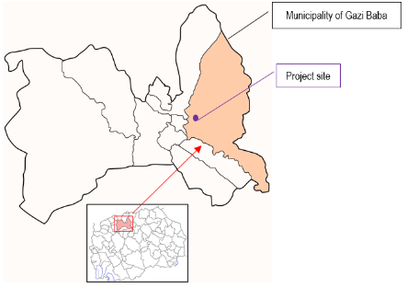

Figure 1 Location of the project area in relation with the Municipality of Gazi Baba

### Demography

According the 2002 census, the municipality has 72,617 inhabitants and it is one of the largest and most populated within the City of Skopje and within the RNM. Demographic structure of MGB by ethnicity is: Macedonians 73.5%, Albanians 17.3%, Serbs 2.9%, Roma 2.9%, Turks 0.8%, Vlachs 0.3%, Bosnians 1.0% and other 1.3%. The average number of households is 3.5. The population density of the municipality is 789 people/km2. Average population age is 35.4 years, up to 20 years are 27.4 % of total population of Municipality of Gazi Baba, up to 40 years are 58.6% of total population of Municipality of Gazi Baba, more than 60 years are 14.4% of total population of Municipality of Gazi Baba. According to the gender structure, the male population of the municipality is 38,144 citizens and females population is 38,865.

### Climate features

The average annual temperature in the Municipality of Gazi Baba is 12.50C. The average monthly temperature in the winter is above zero and the coldest month is January with an average temperature of 0.40C. The annual maximum temperature is 42.40C. On average, there are 117 summer days in the municipality. Temperature inversions occur every month, most often during the winter. The lowest temperatures during the day when temperature inversions occur are recorded in the lower parts of the valley, while the temperature is higher in higher places. The inversion temperature difference between the lowest part of the valley and the surrounding highlands during the winter can exceed 10ºC, depending on the intensity of the inversion. The average frost period lasts 84 days. During the summer period, electricity consumption increases due to high temperatures. On the other hand, the heating season lasts 6 months. The minimum annual air temperature is - 22.90C. The average relative humidity during the year is 70%. The lowest relative humidity was registered in July and August - from 54% to 69%. The average annual number of clear days is 70, and the number of cloudy days is 107.

Precipitation is unevenly distributed throughout the year (monthly and seasonal). The heaviest rainfall occurs in May and October. The lowest values are registered in February and July. According to the ombrographic measurements in the Skopje valley, the precipitation is more frequent and heavier at noon compared to the mornings. During the warm period of the year, there is heavy (torrential) rains with different intensity and duration.

The most characteristic winds are for the territory of the Municipality of Gazi Baba are following: Povardarec, Jugo and wind from the north-west.

Floods and landslides risk

Municipality of Gazi Baba is part of Skopje Planning region. The territory of City of Skopje is known for strong earthquakes (in 1963) and the latest flood event near village Stajkovci (in 2016). In Figure 2 is given map of floods and erosion risk of RNM.



*Source:* [*http://app.gov.mk/wp-content/uploads/2015/04/%D0%9030104-PP-na-RM-2002-2020.pdf*](http://app.gov.mk/wp-content/uploads/2015/04/%D0%9030104-PP-na-RM-2002-2020.pdf)

Figure 2 Map with potential natural hazards (erosion, floods, landslides and earthquakes) in RNM

According to Figure 2, the area of project location in Municipality of Gazi Baba is characterized with **high risk of floods and earthquakes**.

### Seismology

According to the seismic activity so far the territory of the Municipality of Gazi Baba, where the project is located, belongs to areas subject to frequent and strong earthquakes, caused by local and distant epicenter hotspots. In this area, shocks are possible with a magnitude of IXᵒ per MK scale.

### Water

The territory of the Municipality of Gazi Baba abounds with larger and smaller rivers, streams and groundwater, especially on the mountain Skopska Crna Gora. Most of the watercourses are of occasional nature.  
Among the more significant surface watercourses on the territory of the Municipality of Gazi Baba are the river Vardar, as well as the smaller watercourses Rastanski stream (in the village Rastak), Straska (Bulachanska) River (in the village Bulachani) and Creshevska River (village Stajkovci). The Vardar River is the southern border of the Municipality of Gazi Baba with the municipalities of Centar and Aerodrom. The waters of the river Vardar are not used for irrigation due to the big pollution.

Rashtanski Stream, which is a small and permanent stream, springs at 1,500 m a.s.l. from 4 springs: Delidere, spring Rastak, Kolesh Mara 1 and Kolesh Mara 2. The length of the watercourse is 4.7 km, and the catchment area is 3.92 km2. Strashka (Bulachanska) River springs north - east of the village. Bulachani is the left spring branch of the Bulachanska River. The length of the watercourse is 2.5 km and the area of ​​the watershed is 4.5 km2. Part of the waters of the Bulachanska River are used for irrigation.

### Air quality

In the Republic of North Macedonia, monitoring of the ambient air quality is performed by the Ministry of Environment and Physical Planning. The ministry manages the State automatic air quality system composed of 17 measuring stations of which 5 are located in City of Skopje. The nearest monitoring station that monitors the ambient air quality in the Municipality of Gazi Baba is the monitoring station Gazi Baba, located about 1.7 km northwest from the project site. The measuring air station Gazi is located on a hill in the north-western part of Skopje, near the Faculty of Natural Science and Mathematics, in Skopje. There is a parking lot at the distance of 20 m. In the district of Zhelezara, north-west of the station, there are metallurgy industries at a distance of 2 km. The distance to the main road (Boulevard Alexander of Macedon) is 300 m and the distance to the nearest residential houses is approximately 100 m. This suburban background station represents the overall city background concentrations influenced by the integrated contribution from all sources. This measuring station provides results for the concentrations of the following parametars: NO2, SO2, CO and PM10

The sources of suspended particles are burning of fossil fuels and biofuels, different industrial processes, traffic, incineration of waste and wild fires. One of the most important sources is heating of homes and administrative capacities, mainly due to the incomplete incineration of wood in the old furnaces. The number of times the average daily threshold limit value of PM10 at the Gazi Baba measuring point in 2019 was exceeded for 36 days.

In the Republic of North Macedonia, the key and dominant source of sulphur oxides in the air are the processes of burning of fuels (coal and fuel-oil). The average daily SO2 concentrations at this measuring station have not exceeded the threshold value for the year of 2019. The concentrations of CO at this measuring station, no exceedances were registered in 2019. The 8h threshold limit For the 1 hour average values of NO2 for the year of 2019, there was one hour exceedance of the upper threshold limit.

### Waste

The management of the municipal waste in the Municipality of Gazi Baba is in the full competence of the PCE "Communal Hygiene", Skopje. The regular service for collection and transport of waste from households, industrial and commercial facilities, as well as from health care institutions is performed without primary selection and recycling and is disposed at city landfill “Drisla” (located by the basin of the river Markova, on the opposite downhill side of the village Batinci, 14 km southeast of the Skopje’s center).

### Geology and soil

According to the data from the regional geological research shown on the Basic Geological Map of Skopje, the soil in the Skopje Basin is created from massive rocks from the Paleozoic and Mesozoic. The basic geological environment of the widespread Skopje region consists of Neogene-Pliocene sediments and Quaternary-alluvial deposits. The basic massive rocks are the Pliocene lake sediments that are at 700 m covered with Quaternary mostly alluvial-terraced sediments. The characteristics of the Quaternary sediments of the upper layers are determined by layers of gravel, sand and clay up to the surface of the terrain. This genesis is related to the alluvial flow of the river Vardar as well as to the flood sediment from the surrounding catchment areas. The Paleozoic complex includes: marble and quartz, which together stretch from north-east to south-west direction.

Generally, the soil at the site is composed of proluvial deposits represented by fine-grained clay mixtures and gravel admixtures. The geomechanical properties of these deposits are relatively weak, due to the narrow angles of internal friction and the weak pressure modules. Therefore, these layers can only be used for small specific loads. Beneath this layer is a compact layer of gravel deposits and sandy mixtures including fine particles.

### Flora and fauna

In the wider surrounding of the project site are located protected area “Ostrovo” - including Arboretum and Ezerce area (about 3.2 km southeast from the project site) and forest park “Gazi Baba” (about 1.1 km west from the project site).

**Protected area “Ostovo”**

The Monument of Nature (MP) "Ostrovo" was declared a protected area in 1976 by the Assembly of the City of Skopje (III degree of protection which is equivalent to category III according to IUCN). This area covers 0.29 km2 and is a relic ecosystem (specific flora and fauna) of the former riverbed of the river Vardar. The Ostrovo area is a remnant of a former island that was naturally formed by the river Vardar, which separated into two streams and surrounded the island. Today, the fossil riverbeds of the river are preserved on the field, covered with humus layer, foliage and are overgrown with grass and bush vegetation due to which the island is treated as a fossil island on the river Vardar. In Figure 3 is presented some of the vegetation type within the protected area “Ostrovo”.

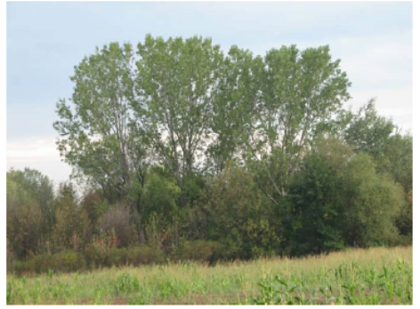

Figure 3 Part of the vegetation in protected area “Ostrovo”

There are two types of biotopes in the locality: grass and arboreal type. In addition to their artificial formation, a process of natural renewal of part of the dendro-flora is taking place. On the ground floor there are many grass species of the family (*Poaceae*). The parts of the land that are not completely suitable for agricultural production are rich in weed and mining vegetation. The vegetation ass. *Geranio-Sylibetum mariani*) is a significant part of the overall flora-vegetation diversity in this area. Other representatives of the flora are represented: soap dish, wolf apple, tanacetum, snake grapes. From the woody plants and shrubs in the locality are represented: black ash, elm, rosehip, elm, maple (*Acer negundo*), acacia, white poplar (*Populus alba*), black poplar (*Populus nigra*), scream, white willow (*Salix alba*).

10 species of butterflies and two species of dragonflies have been registered on the site. Other insects are common: the great scorpionfish and 22 species of locusts. From the mollusks there are 3 species of land snails, one of which is the Balkan endemic. Herpetofauna (amphibians and reptiles) in the locality is represented by 6 species. The ornithofauna in the locality is represented by 55 species of birds while the mammals in the locality are represented by 20 species of which 14 species are micro mammals (horseshoe bats, nightingales, evening primroses) and 5 species of macro mammals (colorful marten, badger, wild cat, white marten, squirrel and hedgehog).

According to the international status of the species diversity, it has been concluded that on the locality Ostrovo there are species of fauna that are important for the biodiversity of N. Macedonia, but also beyond, at European and world level. Namely, 6 species of herpetofauna have the status of protected species in Europe. There are 4 types in Annex II of the Bern Convention; in Annex III of the same convention are 2 species, and in the list of CORINE biotopes are 3 species. From the terofauna in the locality, 14 species of international importance have been singled out, out of which in the world list of endangered wild animal species are 11 species, in Annex II of the Bern Convention are 3 species, in Annex III are 4 species, and in the CORINE list are 11 species . Namely, 9 species of bats and 2 species of other mammals have the status of endangered, ie vulnerable. 27 species of birds of international importance have been singled out from the ornithofauna in the locality.

**Arboretum**

The arboretum was established in 1953 by the Faculty of Agriculture and Forestry in Skopje. In fact, the arboretum is a continuation of the vegetation belt formed by the sites Ostrovo and Ezerce on the west side. In the arboretum are planted woody and shrub species of our dendroflora and species from all continents, especially from Europe, Asia and North America. The total number of woody and shrub species in the Arboretum is about 600 species. Dendro - park serves for environmental observations, scientific research at the Forest Experiment Station Trubarevo and teaching for students at the Faculty of Forestry - Skopje

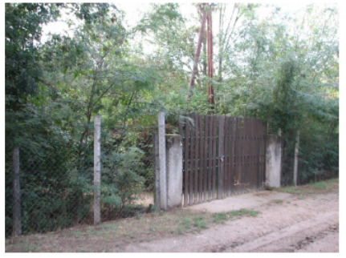

Figure 4 Part of the Arboretum, which is part of the protected area “Ostrovo”

**Ezerce**

The site is also characterized by significant ecological, educational and recreational values ​​due to which in 1994 together with the Arboretum it was declared a protected area in the category of natural monument. The site Ezerce is under water all year round and in the summer the water is retained only in the lower places. The substrate is quite wet throughout the year and in it develops typical swamp vegetation with dominance of reeds (Phragmites australis) and hornbeam (Typha latifolia). , especially in summer. Dominant species are: white willow, brittle willow, white poplar, black poplar, elm, and there are also birch, maple, elm and acacia.

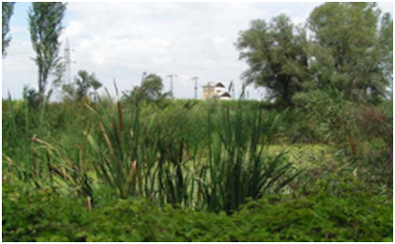

Figure 5 Part of Ezerce, which is part of the protected area “Ostrovo”

### Noise

In the RNM only in some of the bigger cities like Skopje, Kichevo, Kumanovo and Bitota, the environmental noise is monitored, whereas in the Municipality of Gazi Baba there are no monitoring stations, therefore the noise pollution is not monitored.

### Cultural heritage

Archaeological sites on the territory of the Municipality of Gazi Baba originate from prehistory and antiquity. Numerous archeological sites are spread throughout the Municipality and are a rare material evidence of the spiritual and material culture of the people who lived here two millennia ago. One of the most significat Archaeological sites is Tumba site.

Tumba, a settlement from Neolithic times. It is located at the northeastern end of Skopje, in the area between the modern settlements Madzari 2 and Cento, next to the football field. It was concluded that these are the remains of a multi-layered settlement, with a cultural layer of 3 m in which three living horizons from the Middle Neolithic period are distinguished. A large number of remains of ceramic vessels were found, and cult plastic was also discovered. The great mother goddess, the protector of fertility, is represented in a way that is currently unknown among the Neolithic cultures from other Balkan areas.

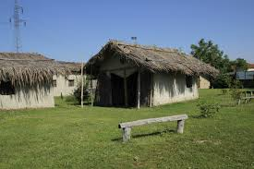 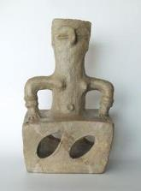

Figure 6 Tumba – archeological site

## Project location

Planned reconstruction activities, will be implemented north part of the City of Skopje, within the Municipality of Gazi Baba. More precisely, the project site is located in the west part of the municipality, at the Blvd. Kiro Gligorov.in total length of 730.12 m. The macrolocation of the project site is presented in Figure 7.

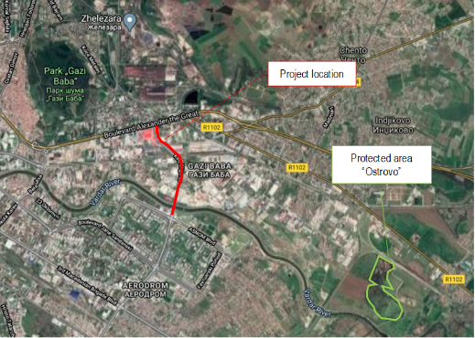

Figure 7 Macrolocation of the project site in Municipality Gazi Baba

The project site represents one of the most frequent traffic roads within the capital city of RNM – Blvd. Kiro Gligorov. The route of the project site starts from bridge “Bliznak” and ends as a junction to the overpass on Blvd. Aleksandar Makedonski, in total length of 730.12 m and width of 14m (2x7 m). The road surface is in relative good condition, but cracks and damages are evident as result of the frequent and heavy vehicles movements at this street/boulevard. Along the project site, mostly industrial/commercial facilities are located. At the beginning of the route of the street/boulevard river Vardar and FON University are located. In the close surrounding of the project site, residential facilities, church, accommodation facility, recreation park, etc. are located. In the wider surrounding of the project site are located following: protected area “Ostrovo” (about 3.2 km southeast from the project site); forest park “Gazi Baba” (about 1.1 km west from the project site); private hospital “Re-Medika” (about 1.3 km northwest from the project site); etc.

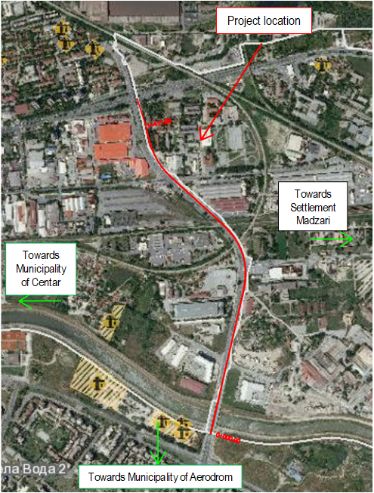

Figure 8 Micolocation of project site in Municipality of Gazi Baba

In order to provide screening of the current condition of the project area, PIU from the MTC and responsible staff from Municipality of Gazi Baba, conducted a site visit of the project location of Blvd. Kiro Gligorov, from the Bridge “Bliznak” to the overpass on Blvd. Aleksandar Makedonski” in Municipality of Gazi Baba. Following situation of the project location was noted:

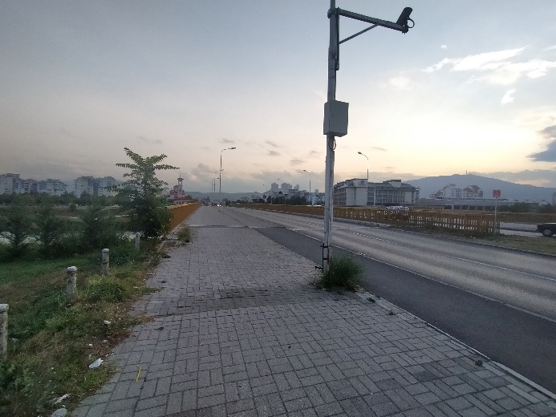 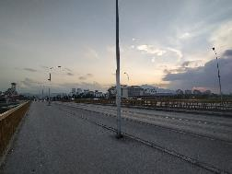 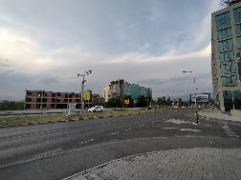 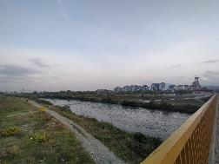 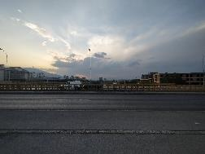 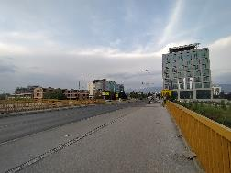

River Vardar

FON University

a) site visit photos from the strat point of the project site

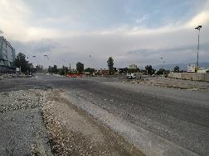 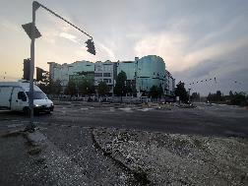

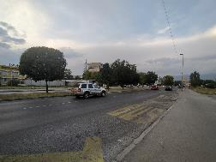 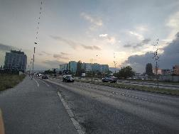

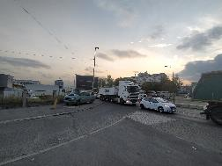 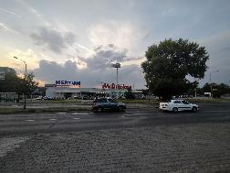

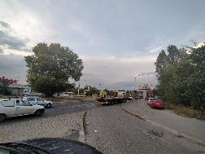 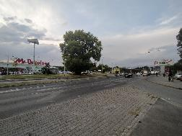

b) site visit photos in the middle part of the project site

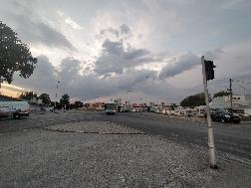 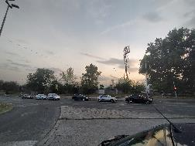

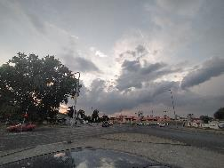 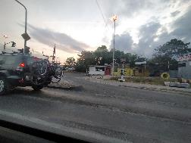

c) site visit photos near the end point of the project site

Figure 9 Current situation of the project area Municipality of Gazi Baba

From the presented site visit photos, it is evident that the reconstruction of the project location is necessary.

## Project Activities

In Table 1 main project activities are given. They will be implemented in three project phases: preparation activities (marking out and securing the project site, clearing out the route of the road, etc.), upgrading of the street and operational phase – activities related to regular and preventive maintenance.

Table 1 Planned project activities in Municipality of Gazi Baba

|  | **Project phases** | | |
| --- | --- | --- | --- |
| ***Preparatory activities*** | ***Reconstruction phase*** | **Operational phase** |
| **Project Activities** | * Marking and securing the route at the project location; * Putting up security and alert signalization along the route of the project area. | * Asphalt scraping and clearing of the scrapped areas (2.271 m3 ); * Putting on buffer layer; * Coating of the scrapped areas and buffer layer with bitumen emulsion; * Placing a bearing bitumen layer over existing road. | * Clearing out the project location from the generated waste streams. |

Taking into account the type and volume of the project activities and sensitive receptors, potential environmental impact and risk can be easily identified and assess. The expected environmental impacts from the implementation of the project activities are presented below.

## Sensitive receptors

Several sensitive receptors have been identified as result of the realization of the project phases:

* Local population, who lives in the close surrounding of the project site;
* Local population that uses the road to go to work;
* Students that will be going to the private university “FON”;
* Workers, who will be working on the boulevard during the reconstruction activities.

As result of the implementation of the upgrading project activities, these sensitive receptors will be affected from several environmental impacts and risks are presented below, by aspects.

# POTENTIAL ENVIRONMENTAL IMPACT AND RISK AND IMPACT AND RISK ASSESSMENT

For this sub – project land acquisition is not envisaged as the property of the land where the local street is located is state owned.

For the needs of the Contractor for temporary placement of machinery and equipment at a location in the immediate vicinity to the project that is privately owned (if there is a need), it is necessary to sign a Contract with the owner of the parcel for temporary land usage during project implementation period. The Contract will define terms and obligations for land usage or other premises (ex. garage, storage area, etc.) in line with the Project RPF Furthermore, all compensation will be paid before the respective land is accessed.

Increased level of noise, air emissions, possible improper waste management, OH&S risk and risk on local community safety are main identified adverse environmental impacts and risks. Detailed analyses of each possible impact and risk is shown by aspects, below. The presentation of the possible impacts and risk is shown in Table 2.

Table 2 Possible environmental impacts and risks

|  |  |  |
| --- | --- | --- |
| *Possible impacts* | | |
| *Preparatory phase* | ***Upgrading phase*** | ***Operational phase*** |
| * *OH&S risk for the workers and local community safety of the population (especially near university “FON”)* | * *OH&S risk,* * *Community safety risk,* * *Air quality,* * *Noise,* * *Waste generation,* * *Water pollution.* | * *Local community safety,* * *Noise* |

**Aspect: OH&S and local community safety**

The Contractor has an obligation to prepare and implement of the **OH&S Plan including Labor management procedures**, **Community safety Plan** (withproper preventive measures) and to implement good international industry practice, before the sub-project activities. The **Community safety plan** should contain information on the safety measures around the project site especially for the students in order to provide proper schedule to avoid possible injuries. *In order to prevent possible risk on students (who visit the FON university), the Contractor should schedule the project activities in the period, when the frequency of the students is decreased.* The project site needs to be secured and marked by the Contractor i.e. place alert signalization. In order to prevent possible injuries to the sensitive receptors and to insure that project activities will run smoothly it is necessary to have good communication between the Contractor and the local representatives of local self-government of Municipality of Gazi Baba. The local population (especially students and the people that use the boulevard to go to work) should respect the preventive measures given from the Contractor. **Traffic Management Plan (TMP)** with time schedule of project activities and directions for re-routing the traffic flow should be prepared by the Contractor so that smooth transport of people and goods across the project location will be provided. On the municipal web page ([http://www.gazibaba.gov.mk/mk#](http://www.gazibaba.gov.mk/mk)), **Information note/Press** release will be posted, and it should contain description of the type of the sub-project activities in order to provide uninterrupted flow of project activities.

Workers should wear PPE. They also must be informed on existence of Grievance Redress Mechanism, as well as the right to organize in workers organization, by their employer the Contractor/Sub-contractor. All engaged workers must have regulated full employment status during their assignation on this project, and all their health and pension insurance must be covered in full for the engaged period by their employer.

In addition to the measures for safety and protection at work, takin into consideration of the current situation with COVID 19 the number of cases is decreasing, so on 24th of September there are 2.176 active cases, total deaths 712 and total number of healed persons is 14.312), the measures for prevention of COVID 19 should be included. The CОVID 19 prevention measures contain recommendations from the World Bank / WHO, as well as recommendations from the Macedonian Occupational Safety and Health Association in the form of a Guide that the Contractor of the construction works needs to implement. The Contractor is required to follow/update and implement the measures that are currently in force and adopted by the Government as binding at national level. Official site for information related to COVID 19 on national level is [www.koronavirus.gov.mk](http://www.koronavirus.gov.mk).

Detailed description of the measures and recommendations from the World Bank/WHO and MOSHA are presented in Annex 1.

**Aspect: Air quality**

During the preparatory and reconstruction project activities the possible **air emissions** will be caused by the operation of the mechanical machinery and equipment (dust and gas emissions). During the operational phase the air emissions will be mostly generated by mobile sources like the vehicles using the bulevard. For the prevention and mitigation of the adverse environmental impacts the Contractor should see the Mitigation Plan (table below).

**Aspect: Noise**

The operation of the heavy construction machinery and equipment will also generate increased **level of noise** and vibrations. Taking into consideration the noise sensitivity of the project location and national legislation for noise protection (Official Gazette of RM No.79/07, 124/10, 47/11, 163/13 and 146/15) the project site in Municipality of Gazi Baba is considered to be an area with III degree of noise protection because of the mixed area with presence of industrial/commercial facilities, residential facilities, church, accommodation facility, recreation park and private university (the maximum limit values should not exceed 55dB(A) for night and 60dB(A) for evening and day). The Contractor should respect requirements (given in the national and EU guidelines against increased ambient noise) and should undertake mitigation measures in order to prevent adverse noise impacts on the students, local population and workers.

**Aspect: Waste management**

The main **waste streams** that may occur during construction activities are construction and demolition waste (asphalt and cobblestone), communal waste and possible contaminated soil from occasional oil leakage (from construction machinery). The Contractor should respect national regulation requirements for proper waste management. The proper waste management can be carried out trough: categorization of waste streams (according List of Waste codes – Official Gazette of RM No.100/05), separation and recycle of the waste streams, transportation and final disposal of the waste stream at appropriate landfill (this process will be performed from PCE “Communal Hygiene", Skopje on city landfill in Drisla). Also during project activities, the Contractor should sign contract with an authorized legal entities for collection of different waste streams. The estimated quantities of the generated waste according to the Main Design are: 1.620 m3 (removal of the existing asphalt - 17 09 04); 2.280 m2 (scraping of the existing asphalt - 17 09 04); 780 m (removal of concrete curbs); and 2.065 m3 (excavation of soil - 17 05 04).

**Aspect: Water**

Near the bridge “Bliznak”, passes river Vardar. At this point of the route of the bulevard, the river Vardar is overloaded with organic matter from the presence of several waste water outlets, near the bridge “Bliznak”. The water categorization of these water bodies is IV class (highly eutrophic water, with high level of contamination and organic load, and low level of autopurification) according Regulation for Categorization of Water Courses and Lakes - Official Gazette of the RM No. 18/99. Despite this conclusion, in order to prevent additional water pollution of the river Vardar, the Contractor should forbid temporary or final waste disposal near or in river bands and the accumulation.

**Aspect: Biodiversity (flora and fauna)**

The project implementation shall not cause any adverse impact on the flora and fauna because of the character of the project site – urban area of City of Skopje with frequent traffic flow. Also, the protected area “Ostrovo” is located in the wider surrounding of the project site - about 3.2 km southeast.

**Implementation of ESMP**

A Contract that the PIU will sign with the Contractor for implementation of the project activities, which this ESMP will be part of it. The Contractor is oblige to perform all proposed preventive or mitigation environmental and social measures prescribed in this plan and to keep the evidence of any documents related to applying these measures (e.g., letter asking the municipality for disposal of inert waste, records on OHS training performed for all workers before start of activities, all developed EHS plans, etc.). The OHS training should be organized by the Contractor for all workers prior start the project activities and prior any specific tasks with high health risks. The training should be delivered by the authorized OHS company and everyday OHS risks should be assessed by the Contractor’s OHS responsible person working on the location on daily basis. Evidence for all trainings delivered should be kept.

*Proposed measures within the ESMP will be a mandatory requirement for the Contractor during the implementation of the construction activities.*

The monitoring of the implementation of proposed measures lies to the Supervising Engineer. This monitoring will include visual checking, reviewing the records of evidence that the measures have been applied and ask the Contractor to apply the measures as soon as possible. The non-compliances should be recorded and the Report on any non-compliances should be reported to the municipality (Project Manager) immediately, and the Project Manager will report it to the PIU. The Environmental/Social Specialist engaged by the PIU will report the non-compliance and accidents/ emergencies cases to the Bank immediately upon occurrence. Each non-compliance should be closed with appropriate measure/s and the evidence should be kept. The regular monthly report should contain all environmental and social issues raised during that period and the evidence on solutions should be provided as well.

PIU will have main responsibilities regarding the Project implementation, project coordination, monitoring activities and reporting.

The Environmental/Social Specialist engaged by the PIU will be responsible for ensuring proper environmental management of all project activities, conduct environmental supervision by carrying out document reviews, site visits and interviews with Contractor, Supervising Engineer and municipality staff. She/he will supervise Contractors’ compliance with ESMP and visit the project location at least once a month and the Monitoring Report reflecting main issues and arrangements and timing for their solution will be prepared and submitted to the PIU. The semi-annual Project Report should contain a chapter with Environmental/Social risks/impacts of the project and the status of implementation the ESMP proposed measures.

The municipality has a main role for daily monitoring of project activities engaging the Supervising Engineer and coordinating all activities on location nominating the responsible person – Project Manager.

Regular meetings need to organize by PIU with the Project Manager, Contractor, representatives from MoTC, responsible person from the Municipality of Gazi Baba and the ES specialist on a monthly basis or during any site visit.

All involved stakeholders should provide good and timely communication (Contractor, Supervisor, municipal staff, Environmental Inspector, Communal Inspector, PIU from MoTC and other relevant persons from Municipality of Gazi Baba, which is very important for providing continuous performance of the project activities and successful completion of overall project. The PIU from MoTC and project manager from the Municipality of Gazi Baba will facilitate good communication and coordination of the project activities on spot.

**Grievance mechanism**

A Grievance Mechanism will be introduce by PIU to ensure that it is responsive to any concerns and complaints particularly from affected stakeholders and communities.

For the purposes of receiving comments from the stakeholders (local citizens and workers onsite) PIU establish Grievance Mechanism procedure including the Form for the construction phase of the project (Annex 3) that will be available in electronic form on the MoTC web site (<http://www.mtc.gov.mk/>), Municipality of Gazi Baba ([http://www.gazibaba.gov.mk/mk#](http://www.gazibaba.gov.mk/mk) ) and the Contractors web site.

Grievance Form for the construction phase of the project is prepared for the local population (if an incident or damage to private property occurs) and for the workers (grievance for lack of protective equipment, increased working hours, no period for rest, etc.) who will implement the construction activities.

Before starting with construction activities Contractor should inform the workers about the Grievance Form and the opportunity to express their compliances regarding the operation on the construction site. Local population will be introduced with this possibility by the Information posted on the Informative board within the Local Community, Municipal web site, and via city radio or TV stations.

The PIU will ensure that the GRM is responsive to any concerns and complaints particularly from affected stakeholders and vulnerable groups.

Following steps are to be taken to ensure full GRM functioning:

**Step 1:** Recording received grievance in the GRM registry

**Step 2:** Providing the person who filed the grievance with an acknowledgment of receipt within 5 days of receipt

**Step 3:** Investigating the grievance

**Step 4:** Resolution of Grievance within 15 days of grievance receipt

**Step 5:** Follow up

In cases when the grievance/complaint is indefinite or not clear enough, the PIU will assist and provide advice in formulating/redrafting the submission, in order for the grievance/complaint to become clear, for purposes of an informed decision by the PIU, in the best interests of persons affected by the Project.

If the PIU is not able to address the issues raised by immediate corrective action, a long-term corrective action will be identified. The complainant will be informed about the proposed corrective action and follow-up of corrective action within 25 calendar days upon the acknowledgement of grievance. In situation when the PIU is not able to address the particular issue verified through the grievance mechanism or if action is not required, it will provide a detailed explanation/ justification on why the issue was not addressed. The response will also contain an explanation on how the person/ organization that raised the complaint can proceed with the grievance in case the outcome is not satisfactory. At all times, complainants may seek other legal remedies in accordance with the legal framework of Republic of North Macedonia, including formal judicial appeal.

Grievances can be filled verbally, by phone, in writing (by post or e-mail) or by filling in a grievance form. The grievance form will be made available on the implementing agencies website together with clear information on how feedback, questions, comments, concerns and grievances can be submitted by any stakeholder and information concerning the PIU’s managing of the GRM both in terms of process and deadlines. Furthermore, the website will include the possibility to submit grievances electronically.

In order to capture and track grievances received under the project, a dedicated GRM register is planned. Specifically nominated members of staff will record grievance information in the grievance registry. This will include:

* Number of Grievance
* Date of receipt
* Stakeholder name, sex, age and contact details;
* Date of acknowledgement
* Description of grievance
* Description of action taken
* Date of grievance resolution

The PIU will share the Grievance Registry with the WB on a monthly basis.

**Public disclosure and Citizen Engagement**

The Municipality of Gazi Baba will submit the draft version of this ESMP for review and approval of the PIU Environmental and Social Experts, who then (when confident that the document meets WB quality and content requirements) will submit the draft document for the review and clearance by the World Bank. After the clearance is obtained, the document will be publicly disclosed.

The draft ESMP will be available for the public on web site of the Municipality of Gazi Baba ([http://www.gazibaba.gov.mk/mk#](http://www.gazibaba.gov.mk/mk)) and the web site of the MoTC PIU (<http://www.mtc.gov.mk/>) accompanied by a Form for submitting comments (Annex 2) The social Media channels of the Municipality of Gazi Baba that will be used for the purpose of raising awareness about the Project implementation and identified E&S risks, impacts and mitigation measures is the Facebook page (<https://www.facebook.com/opstinagazibaba/>), twitter (<https://twitter.com/opstinagazibaba> )

During the 14 days after the disclosure of the prepared ESMP document, the Municipality of Gazi Baba will conduct video public consultation in order to inform the public on the proposed sub-project activities, anticipated impacts and the ways of their mitigation.

Public announcement will be developed with brief description about the purpose of the project, project activities and duration of the activities, environmental and social impacts, proposed measures, availability of the ESMP together with the Form for submitting comments on the MoTC web site and Municipality web site, Informative board within the Local Community. Announcement will also contain information about the possibility for citizens to raise opinion/ suggestion/comments on the prepared ESMP by filling the Form for comments and submission to the responsible person from MoTC Mrs. Irena Paunovikj (e-mail: [irena.paunovikj.piu@mtc.gov.mk](mailto:irena.paunovikj.piu@mtc.gov.mk) ). Form for submitting can be filled with a full identity or anonymously, and the comment or suggestion should be fully described in order to take it into account in the final version of ESMP. Information about the date and time for conducting the and the video public consultation, way how the stakeholder can take part on the video public consultation will also be a part of the announcement.

Public announcement will be launched on the city radio or TV stations and on the Informative board within the municipality.

**Public consultation for ESMP**

Considering the current situation with COVID 19 and the inability for organizing an ordinary public hearing event in the premises of the Municipality where the project will be implemented, the video public consultation will be organized. The MoTC PIU in cooperation with the municipality will define the date for the video public consultation (by using Vebex operational tool).

Municipality of Gazi Baba will need to inform all relevant stakeholders on its territory about the timing of the video public consultation (and to ask them for their e-mail address if they like to join the event), so that all from their homes/offices can follow the event and be active participants. If the stakeholders do not have the technical capabilities, the municipality will ensure an appropriate solution in order to be able to follow the event. The mailing list for participants will be prepared taking into account all relevant stakeholders and Invitation will be sent to those with brief explanation for the:

* Purpose of the video public consultation;
* Registration link and instructions for connection;
* Exact time and date for the event;
* Availability of the disclosed draft ESMP for comments and
* Possibility for submitting comments on the prepared ESMP by filling in the Form for submitting comments and suggestions on the ESMP to the responsible person from PIU.

During the video consultation event after the presentation of the main project activities and main findings from the ESMP, attending stakeholders can raise their comments/questions/suggestions and any concern about the project.

After maintaining the video public consultation and the 14-day period for submitting comments, the final version of the ESMP will be prepared and will include the public consultation report (including announcement of the event (media or personal) detailed description of the event, list of participants, minutes of meeting, the expressed comments)and the appropriate corrections in the document according to the received comments and remarks.

Approved Final version of ESMP should be included in the Grant Agreement with sub-project proponent, and then into the respective bidding documents and construction contracts. Final version of the ESMP will be available on the MoTC web site and Municipality web site for the whole period of the sub project implementation.

**Contact person for project awareness and public consultation from MoTC:**

**Mrs. Irena Paunovikj**, Responsible for public relations for the project,

e-mail: [irena.paunovikj.piu@mtc.gov.mk](mailto:irena.paunovikj.piu@mtc.gov.mk)

**Contact person for project awareness and public consultation from Municipality of Gazi Baba:**

____________________

e-mail:

mob.tel:

# ENVIRONMENTAL AND SOCIAL MITIGATION PLAN

|  |  |  |  |  |
| --- | --- | --- | --- | --- |
| Potential impact | | Impact scale | Proposed mitigation measures | Responsibility |
| *Project activity: Marking out the route for reconstruction of Blvd. Kiro Gligorov, from the Bridge “Bliznak” to the overpass on Blvd. Aleksandar Makedonski” in Municipality of Gazi Baba, in City of Skopje* | | | | |
| Aspect: OH&S issues and local community safety | ***Expected impact:***  Possible adverse safety and health impacts to the workers and local populationin reconstruction phase of the boulevard due to:   * Lack of ensured safety measures at the start of construction work * Injury passing nearby the construction site * Not compliance with strict OHS standards and work procedure * inadequate public access within the project site in Municipality of Gazi Baba | **Local/ short term/major with moderate significance along the Blvd. Kiro Gligorov, from the Bridge “Bliznak” to the overpass on Blvd. Aleksandar Makedonski where the project activities will be performed** | * Preparation, approval of **Occupational Health and Safety and Plan** (**or Labor Management Procedures**), **Community safety Plan and Waste Management Plan** before the start of the construction activities; * Preparation of **Traffic Management Plan** before the start of the reconstruction activities; * Set up information to local population about the type and time duration on project activities on the municipal information board and the municipal web site of Municipality of Gazi Baba: [http://www.gazibaba.gov.mk/mk#](http://www.gazibaba.gov.mk/mk) ; * **COVID 19 measures for the workers at the construction site are presented in the Annex 1;** * **Set up for the local population safe pathways to have a safe access to move around the project site;** * Implementation of measures for good construction practice during the marking of the local road: * Fencing and placing adequate warning tapes and signs around the project site, * Set the Information panel on project site with general information of the project, the Contractor and Supervisor; * Obligatory application of good construction practice and application of safety measures such as: a) use of proper protective clothing and equipment by worker (PPE); b) Maintain a good level of personal hygiene; c) Health protection-first aid kits and medical service on sites need to be provided during the works; * Protection of pedestrians, local population - fence the project location and prevent access of non-authorized personnel to construction site; * Maintaining a clean construction site, without waste disposed. The waste needs to be collected and immediately removed in order to prevent possibility of injuries; * Maintaining of the mobile toilet should be placed on the construction site; * Machines should be handled only by experienced and trained personnel, thus reducing the risk of accidents; * Constant presence of firefighting devices should be ensured in case of fire or other damage; * All workers must be familiar with the fire hazards and fire protection measures and must be trained to handle fire extinguishers, hydrants and other devices used for extinguishing fires; * Larger quantities of flammable liquids should not be kept on the site along the project site. | * Contractor –Bidder/sub-contractor * Supervisor * Municipal staff (Communal Inspector/Environmental Inspector) |
| *Project activity: Reconstruction of Blvd. Kiro Gligorov, from the Bridge “Bliznak” to the overpass on Blvd. Aleksandar Makedonski” in Municipality of Gazi Baba, in City of Skopje* | | | | |
| Aspect: Air quality | ***Expected impact:***  Possible emissions by transportation vehicles and impact on air quality in the project area (along the route of the boulevard) due to:  Gases emissions of operation with construction machinery CO2, NOx, PAH, SO2 and suspended particulates (PM10, PM2.5). | **Local/ short term/major with high significance, within the project site in Municipality of Gazi Baba** | * Construction site, transportation routes and materials handling sites should be water-sprayed on dry and windy days; * Construction materials should be stored in appropriate places covered to minimize dust; * Vehicle loads likely to emit dust need to be covered; * Usage of protective masks for the workers if the dust appears; * Restriction of the vehicle speed within the construction sites; * Perform regular maintenance of the vehicles and construction machinery in order to reduce the leakages of motor oils, emissions and dispersion of pollution; * Burning of debris from ground clearance not permitted. | * Contractor –Bidder * Supervisor |
| Aspect: Waste | ***Expected impact:***  Possible adverse environmental impact and health effects could occur as a result of generation of the different waste streams  The inappropriate waste management and not in time collection and transportation of waste streams | **Local/short term/ with major significance within the project location, at the boulevard in City of Skopje, in Municipality of Gazi Baba** | * Identification of the different waste types at the project site (soil, asphalt, food, etc.); * Classification of waste according the national List of Waste (Official Gazette no.100/05); * The main waste would be classified under the Waste Chapter 17 “Construction and demolition wastes (including excavated soil from contaminated site)” with the waste code 17 05, 17 05 06 - Excavated soil, 17 09 04 – Mixed waste from construction sites and will be stored and temporary disposed in separate appropriate containers depending on the waste characteristics on the project location until final disposal by the public enterprise; * Small amount of solid municipal waste could be found (food, beverages), as well as packaging waste (paper, bottles, glass, etc.). * Collection, transportation and final disposal of the inert and communal waste will be performed by PCE “Communal Hygiene” from Skopje, at city landfill “Drisla” (located by the basin of the river Markova, on the opposite downhill side of the village Batinci, 14 km southeast of the Skopje’s center).; * The recycle and re-use of some waste materials is obligatory (not to dispose them as a waste) and will be determined in the Waste Management Plan (such as plastic and paper will be stored in separate containers and the excavated soil will be reused on different locations); * The possible hazardous waste (motor oils, vehicle fuels) should be collected separately by an authorized collector and transporter that should be sub-contracted by the Contractor to transport and finally dispose the hazardous waste; * The materials should be covered during the transportation to avoid waste dispersion; * Burning of construction waste should be prohibited. | * Contractor - Bidder * Supervisor * Municipal staff (Environmental Inspector and Communal Inspector) * PCE “Communal Hygiene” from Skopje |
| Aspect: Noise disturbance | ***Expected impact:***  Possible noise disturbance as a result of outdoor equipment usage and transportation vehicles driving around the project site | **Local/ short term /with major significance/ along the project location in Municipality of Gazi Baba** | * The equipment should be fitted with appropriate noise devices that will reduce sound level; * Taking into consideration the noise sensitivity of the project location and national legislation for noise protection (Official Gazette of RM No.79/07, 124/10, 47/11, 163/13 and 146/15) the project site in Municipality of Gazi Baba is considered to be an area with III degree of noise protection because of the mixed area with presence of industrial/commercial facilities, residential facilities, church, accommodation facility, recreation park and private university (the maximum limit values should not exceed 55dB(A) for night and 60dB(A) for evening and day); * The control of noise level should be performed during work peaks; * The construction work should be not permitted during the nights, the operations on site shall be restricted to the hours 7.00 -19.00; * The vehicles that are excessively noisy shall not be operated until corrective measures have been taken. | * Contractor –Bidder * Supervisor |
| Aspect: Water quality | ***Expected impact:***  Possible environmental impact on the relevant water recipients could occur due to ground contamination (from the spillage of materials such as vehicle fuel, motor oils and lubricants) and waste disposal near or in river band of river Vardar | **Local/Short term/at the beginning of the route of the boulevard, near bridge “Bliznak”**  **High significance/** | * The possible hazardous waste (motor oils, vehicle fuels) should be stored in leakproof containers and collected separately by an authorized collector and transporter that should be sub-contracted by the Contractor to transport and finally dispose the hazardous waste; * According to national legislative for waste management, it is forbidden temporary or final disposal in or near the river bands of the river Vardar. The different streams of waste should be stored in separate appropriate leak proof containers depending on the waste characteristics on site; | * Contractor –Bidder * Supervisor |
| *Operational phase: Operation of* *Blvd. Kiro Gligorov, from the Bridge “Bliznak” to the overpass on Blvd. Aleksandar Makedonski in Municipality of Gazi Baba* | | | | |
| The implementation of the mitigation measures in the operational phase of the boulevard is necessary and should include: placement of the horizontal and vertical traffic signalization for speed limitation of the vehicles; implementation of road speed limitation barriers (speed road barriers, road shoulders, etc.). All mitigation measures should be in compliance with national regulative for traffic safety - Law for road traffic safety (Official Gazette of RM, No.54/07, 86/08, 98/08, 64/09, 161/09, 36/11, 51/11,114/12, 27/14 and 169/15). | | | | |

# ENVIRONMENTAL AND SOCIAL MONITORING PLAN

| **What**  **parameter to be monitored?** | **Where**  **is the parameter to be monitored?** | **How**  **is the parameter monitored?** | **When**  **is the parameter monitored (frequency of measurement)?** | **Why**  **is the parameter monitored?** | **Cost** | | **Responsibility** | |
| --- | --- | --- | --- | --- | --- | --- | --- | --- |
| **Construction** | **Operations** | **Reconstruction of Blvd. Kiro Gligorov, from the Bridge “Bliznak” to the overpass on Blvd. Aleksandar Makedonski” in Municipality of Gazi Baba** | **Operation of Blvd. Kiro Gligorov, in Municipality of Gazi Baba** |
| **Project stage: Marking out the route for reconstruction of Blvd. Kiro Gligorov, from the Bridge “Bliznak” to the overpass on Blvd. Aleksandar Makedonski” in Municipality of Gazi Baba, in City of Skopje** | | | | | | | | |
| Prepared all required documents related to OH&S, Community safety and Traffic Management | Within the project location in Municipality of Gazi Baba | Review of the prepared documentation (OHS Plan  Community safety Plan  Traffic Management Plan (TMP) | During the clean-up activities  At the beginning of each working day during the sub-project activities | To prevent health and safety risks – mechanical injuries  To be in compliance with national communal health regulation and OH&S standards |  |  | Contractor - Bidder  Supervisor  Communal Inspector at the Municipality of Gazi Baba |  |
| **Project stage: Reconstruction of Blvd. Kiro Gligorov, from the Bridge “Bliznak” to the overpass on Blvd. Aleksandar Makedonski” in Municipality of Gazi Baba, in City of Skopje** | | | | | | | | |
| Providing safety traffic flow along the Blvd. Kiro Gligorov, from the Bridge “Bliznak” to the overpass on Blvd. Aleksandar Makedonski | Within the project area in Municipality of Gazi Baba | Visual monitoring | During the working day | To ensure the safety traffic flow through the project location and easy access of local population to their property and public facilities |  |  | Contractor /Sub-contractor Supervisor  Traffic Inspector responsible for the Municipality of Gazi Baba |  |
| Use of PPE | On project site | Visual monitoring | Occasionally, during construction |  |  |  | Contractor /Sub-contractor  Supervisor  Labour Inspector responsible for the Municipality of Gazi Baba |  |
| Providing safe pedestrian track and trespassing corridors | On project site | Visual monitoring | Occasionally, during construction | To ensure the safety traffic flow through the project location and easy access of local population to their homes, work and public facilities |  |  | Contractor /Sub-contractor Supervisor  Traffic Inspector responsible for the Municipality of Gazi Baba |  |
| Primary selection of the generated different waste streams at the project location | Within the reconstruction site | Review the documentation | At the beginning of work with new material/s | In order to ensure separation of hazardous from the non-hazardous waste as well as inert from biodegradable waste |  |  | Contractor – Bidder  Supervisor |  |
| Collection and transport of hazardous waste (if any occurs) | On safety temporary storage | Review the transportation list and conditions at the storage facility | Before the transportation of the hazardous waste (if there is any) | To improve the waste management practice on municipality and national level/ Not to dispose the hazardous waste on the waste disposal spots |  |  | Authorized Contractor for collection and transportation of hazardous waste (if any occurs) |  |
| Collection transportation and final disposal of the solid waste | At the project site (at the boulevard “Kiro Gligorov”) | Visual monitoring and reviewing the transportation and disposal lists from the sub-contractor | After the collection and transportation of the solid waste on regular base each day | Not to leave and dispose the waste streams on the sites in order to avoid the environmental and health impact on local population  To have the real data for generated waste streams and to improve the waste management |  |  | Contractor – Bidder  Supervisor and PCE “Communal Hygiene” from Skopje |  |
| Increased level of noise | Along the boulevard (near the university, church, etc.) | With noise measurement calibrated equipment | During the work peaks | To ensure noise level limits according regulation  To prevent noise disturbance |  |  | Contractor - Bidder |  |
| Possible waste disposal (solid and liquid) near or in the river bend of river Vardar | At the beginning of the route of the boulevard, near bridge “Bliznak” | Visual check if the waste is disposed near river Vardar | During the project activities (once per week) | To ensure good status of water quality  To prevent additional water pollution |  |  | Contractor - Bidder  Supervisor |  |
| Fulfilled Annual Report for collection, transportation and disposal of waste | Local self-government administration | Review of documentation – Identification of waste list | After the accomplishment the task of collection, transportation, temporary disposal and final disposal of waste | To improve the waste management on local and national level  To be in compliance with national legal requirements |  |  | Mayor of Municipality of Gazi Baba / Ministry of Environment and Physical Planning |  |
| **Project stage: Operational phase of the Blvd. Kiro Gligorov, from the Bridge “Bliznak” to the overpass on Blvd. Aleksandar Makedonski” in Municipality of Gazi Baba, in City of Skopje** | | | | | | | | |
| Placement of the horizontal and vertical traffic signalization for speed limitation of the vehicles, road speed limitation barriers (speed road barriers, road shoulders, etc.) | Along the boulevard | Decreased number of traffic accidents along the boulevard | Continuously (the parameter should be monitored in compliance with - Law for road traffic safety (Official Gazette of RM, No.54/07, 86/08, 98/08, 64/09, 161/09, 36/11, 51/11,114/12, 27/14 and 169/15). | To achieve safety of the local population and pupils and to be in compliance with national regulative for traffic safety |  |  |  | Ministry of internal affairs (branch office in Municipality of Gazi Baba |

# ANNEX

Annex 1 COVID-19 considerations in construction/civil works projects

Taking into account the new situation with the appearance of the virus COVID 19, besides the standard measures for safety and protection at work it is necessary to implement measures for protection from COVID 19.

Undoubtedly, the Contractors will face many challenges in the new situation, such as:

* Inability to purchase protective equipment and disinfectants due to lack on the market,
* Lack of labour due to limited movement and absences from work,
* Inability to provide materials and work equipment due to congestion in all segments of life in the country,
* Employees' concerns about their livelihoods due to reduced workload, etc.

First, it is necessary to implement the measures for protection from COVID 19 adopted by the Government of the Republic of Northern Macedonia at the proposal of the Commission for Infectious Diseases and the Ministry of Health. **These measures should be constantly updated in accordance with the latest provisions introduced by the Government**. The Contractor is required to nominate a responsible person who will follow the measures adopted by the Government and will apply them in the operation of the construction site at the project location.

Links of the national institutions responsible for COVID 19 where the Contractor could find updated information and recommendations:

* **Government of the Republic of North Macedonia -** [**https://vlada.mk/node/20488?ln=en-gb**](https://vlada.mk/node/20488?ln=en-gb)
* **Ministry of Health -** [**http://zdravstvo.gov.mk/korona-virus/**](http://zdravstvo.gov.mk/korona-virus/)
* **Ministry of Labour and Social Policy -** [**http://mtsp.gov.mk/covid-19.nspx**](http://mtsp.gov.mk/covid-19.nspx)
* **Ministry of transport and communications -** [**http://mtc.gov.mk/Preporaki%20od%20Vlada**](http://mtc.gov.mk/Preporaki%20od%20Vlada)
* **Official site for COVID – 19 -** [**https://koronavirus.gov.mk/en**](https://koronavirus.gov.mk/en)

On national level in addition to the measures introduced by the Government for protection from COVID 19, the Macedonian Occupational Safety and Health Association developed a Guide to Safety and Health at Work in Construction Prevention from the Corona virus. The Guide contains measures that the Contractor is required to implement in order to eliminate the possible ways of obtaining and transmitting COVID 19 among the workers on construction site.

In more detail in several chapters, the Guide contains:

* Challenges in construction;
* Obligations for the Contractor;
* Obligations for workers;
* Liabilities for Investors;
* Ways of proceeding in cases of suspected case or cases infected with COVID 19;
* Contact phones of national institutions responsible for contacting the occurrence of the event infected with COVID 19.

The text of the Guide to Safety and Health at Work in Construction Prevention from the Corona virus on the Macedonian language is given on the following link <http://mzzpr.org.mk/wp-content/uploads/2020/04/covid19-%D0%B3%D1%80%D0%B0%D0%B4%D0%B5%D0%B6%D0%BD%D0%B8%D1%88%D1%82%D0%B2%D0%BE.pdf>.

**The Contractor also needs to implement the requirements introduced by the World Bank related to the protection of COVID 19.**

Regarding the COVID-19 considerations in construction/civil works projects given by the World Bank, they are divided in several segments/issues and in details are shown on Table 3.

Table 3 COVID-19 considerations in construction/civil works projects recommended by WB

|  |  |
| --- | --- |
| *COVID-19 considerations in construction/civil works projects* | |
| Covid-19 issues | **Type of activities** |
| The Contractor should identify measures to address the COVID-19 situation taking into account the location, existing project resources, availability of supplies, capacity of local emergency/health services, the extent to which the virus already exist in the area.  PIU and Contractor should establish specific procedures for addressing COVID 19 issues on the construction site. Procedures should be implemented, documented and updated in accordance with the latest changes introduced by the Government and the conditions on the construction site. | |
| Assessing workforce characteristics | • The Contractor should prepare a detailed profile of the project work force, key work activities, schedule for carrying out such activities, different durations of contract and rotations;  • This should include a breakdown of workers who reside at home (i.e. workers from the community), workers who lodge within the local community and workers in on-site accommodation (i.e. workers camp). Where possible, it should also identify workers that may be more at risk from COVID-19, those with underlying health issues or who may be otherwise at risk;  • Consideration should be given to ways in which to minimize movement in and out of site. This could include lengthening the term of existing contracts, to avoid workers returning home to affected areas, or returning to site from affected areas. |
| Entry/exit to the work site and checks on commencement of work | • Establishing a system for controlling entry/exit to the site, securing the boundaries of the site, and establishing designating entry/exit points (if they do not already exist). Entry/exit to the site should be documented;  • Training security staff on the (enhanced) system that has been put in place for securing the site and controlling entry and exit, the behaviors required of them in enforcing such system and any COVID -19 specific considerations;  • Training staff who will be monitoring entry to the site, providing them with the resources they need to document entry of workers, conducting temperature checks and recording details of any worker that is denied entry;  • Confirming that workers are fit for work before they enter the site or start work. While procedures should already be in place for this, special attention should be paid to workers with underlying health issues or who may be otherwise at risk. Consideration should be given to demobilization of staff with underlying health issues;  • Checking and recording temperatures of workers and other people entering the site or requiring self-reporting prior to or on entering the site;  • Providing daily briefings to workers prior to commencing work, focusing on COVID-19 specific considerations including cough etiquette, hand hygiene and distancing measures, using demonstrations and participatory methods;  • During the daily briefings, reminding workers to self-monitor for possible symptoms (fever, cough, and other respiratory symptoms) and to report to their supervisor or the COVID-19 focal point if they have symptoms or are feeling unwell;  • Preventing a worker from an affected area or who has been in contact with an infected person from returning to the site for 14 days or (if that is not possible) isolating such worker for 14 days;  • Preventing a sick worker from entering the site, referring them to local health facilities if necessary or requiring them to isolate at home for 14 days. |
| General hygiene | • Placing posters and signs around the site, with images and text in local languages (MK/ALB);  • Ensuring handwashing facilities supplied with soap, disposable paper towels and closed waste bins exist at key places throughout site, including at entrances/exits to work areas; where there is a toilet, canteen or food distribution, or provision of drinking water; in worker accommodation; at waste stations; at stores; and in common spaces. Where handwashing facilities do not exist or are not adequate, arrangements should be made to set them up. Alcohol based sanitizer (if available, 60-95% alcohol) can also be used;   * Training workers and staff on site on the signs and symptoms of COVID-19, how it is spread, how to protect themselves (including regular handwashing and social distancing) and what to do if they or other people have symptoms;   • Setting aside part of worker accommodation for precautionary self-quarantine as well as more formal isolation of staff who may be infected. |
| Cleaning and waste disposal | • Providing cleaning staff with adequate cleaning equipment, materials and disinfectant;  • Training cleaning staff on appropriate cleaning procedures and appropriate frequency in high use or high-risk areas;  • Where it is anticipated that cleaners will be required to clean areas that have been or are suspected to have been contaminated with COVID-19, providing them with appropriate PPE: gowns or aprons, gloves, eye protection (masks, goggles or face screens) and boots or closed work shoes. If appropriate PPE is not available, cleaners should be provided with best available alternatives;  • Training cleaners in proper hygiene (including handwashing) prior to, during and after conducting cleaning activities; how to safely use PPE (where required); in waste control (including for used PPE and cleaning materials);  • Any medical waste produced during the care of ill workers should be collected safely in designated containers or bags and treated and disposed of following relevant requirements (e.g., national - <http://www.moepp.gov.mk/?nastani=%d0%bf%d1%80%d0%b5%d0%bf%d0%be%d1%80%d0%b0%d0%ba%d0%b8-%d0%b7%d0%b0-%d1%83%d0%bf%d1%80%d0%b0%d0%b2%d1%83%d0%b2%d0%b0%d1%9a%d0%b5-%d1%81%d0%be-%d0%be%d1%82%d0%bf%d0%b0%d0%b4-%d0%b7%d0%b0-%d0%b3%d1%80>,  WHO). If open burning and incineration of medical wastes is necessary, this should be for as limited a duration as possible. Waste should be reduced and segregated, so that only the smallest amount of waste is incinerated. |
| Adjusting work practices | • Decreasing the size of work teams;  • Limiting the number of workers on site at any one time;  • Changing to a 24-hour work rotation;  • Adapting or redesigning work processes for specific work activities and tasks to enable social distancing, and training workers on these processes;  • Continuing with the usual safety trainings, adding COVID-19 specific considerations. Training should include proper use of normal PPE. While as of the date of this note, general advice is that construction workers do not require COVID-19 specific PPE, this should be kept under review;  • Arranging (where possible) for work breaks to be taken in outdoor areas within the site;  • Consider changing canteen layouts and phasing meal times to allow for social distancing and phasing access to and/or temporarily restricting access to leisure facilities that may exist on site, including gyms;  • At some point, it may be necessary to review the overall project schedule, to assess the extent to which it needs to be adjusted (or work stopped completely) to reflect prudent work practices, potential exposure of both workers and the community and availability of supplies, taking into account Government advice and instructions. |
| Project medical services | • Expanding medical infrastructure and preparing areas where patients can be isolated. Isolation facilities should be located away from worker accommodation and ongoing work activities. Where possible, workers should be provided with a single well-ventilated room (open windows and door). Where this is not possible, isolation facilities should allow at least 1 meter between workers in the same room, separating workers with curtains, if possible. Sick workers should limit their movements, avoiding common areas and facilities and not be allowed visitors until they have been clear of symptoms for 14 days. If they need to use common areas and facilities (e.g. kitchens or canteens), they should only do so when unaffected workers are not present and the area/facilities should be cleaned prior to and after such use.  • Training medical staff, which should include current WHO advice on COVID-19 and recommendations on the specifics of COVID-19. Where COVID-19 infection is suspected, medical providers on site should follow WHO interim guidance on infection prevention and control during health care when novel coronavirus (nCoV) infection is suspected;  • Assessing the current stock of equipment, supplies and medicines on site, and obtaining additional stock, where required and possible. This could include medical PPE, such as gowns, aprons, medical masks, gloves, eye protection, etc..;  • Review existing methods for dealing with medical waste, including systems for storage and disposal. |
| Local medical and other services | • Conducting preliminary discussions with specific medical facilities, to agree what should be done in the event of ill workers needing to be referred;   * Obtaining information as to the resources and capacity of local medical services (e.g. number of beds, availability of trained staff and essential supplies);   • Clarifying the way in which an ill worker will be transported to the medical facility, and checking availability of such transportation;  • Agreeing with the local medical services/specific medical facilities the scope of services to be provided, the procedure for in-take of patients and (where relevant) any costs or payments that may be involved;  • A procedure should also be prepared so that project management knows what to do in the unfortunate event that a worker ill with COVID-19 dies. While normal project procedures will continue to apply, COVID-19 may raise other issues because of the infectious nature of the disease. The project should liaise with the relevant local authorities to coordinate what should be done, including any reporting or other requirements under national law; |
| Instances or spread of the virus | **• If a worker has symptoms of COVID-19 (e.g. fever, dry cough, fatigue) the worker should be removed immediately from work activities and isolated on site;**  **• The worker should be transported to the local health facilities to be tested (if testing is available and permitted under national legislation);**  **• If the test is positive for COVID-19 or no testing is available, the worker should continue to be isolated. This will either be at the work site or at home. If at home, the worker should be transported to their home in transportation provided by the project;**  **• Extensive cleaning procedures with high-alcohol content disinfectant should be undertaken in the area where the worker was present, prior to any further work being undertaken in that area. Tools used by the worker should be cleaned using disinfectant and PPE disposed of;**  **• Co-workers (i.e. workers with whom the sick worker was in close contact) should be required to stop work, and be required to quarantine themselves for 14 days, even if they have no symptoms;**  **• Family and other close contacts of the worker should be required to quarantine themselves for 14 days, even if they have no symptoms;**  **• If a case of COVID-19 is confirmed in a worker on the site, visitors should be restricted from entering the site and worker groups should be isolated from each other as much as possible;**  **• If workers live at home and has a family member who has a confirmed or suspected case of COVID-19, the worker should quarantine themselves and not be allowed on the project site for 14 days, even if they have no symptoms;**  **• Workers should continue to be paid throughout periods of illness, isolation or quarantine, or if they are required to stop work, in accordance with national law;**  **• Medical care (whether on site or in a local hospital or clinic) required by a worker should be paid for by the employer.** |
| Continuity of supplies and project activities | • Identify back-up individuals, in case key people within the project management team (PIU, Supervising Engineer, Contractor, sub-contractors) become ill, and communicate who these are so that people are aware of the arrangements that have been put in place;  • Document procedures, so that people know what they are, and are not reliant on one person’s knowledge;  • Understand the supply chain for necessary supplies of energy, water, food, medical supplies and cleaning equipment, consider how it could be impacted, and what alternatives are available. Early pro-active review of international, regional and national supply chains, especially for those supplies that are critical for the project, is important (e.g. fuel, food, medical, cleaning and other essential supplies). Planning for a 1-2 month interruption of critical goods may be appropriate for projects in more remote areas;  • Place orders for/procure critical supplies. If not available, consider alternatives (where feasible);  • Consider existing security arrangements, and whether these will be adequate in the event of interruption to normal project operations;  • Consider at what point it may become necessary for the project to significantly reduce activities or to stop work completely, and what should be done to prepare for this, and to re-start work when it becomes possible or feasible. |
| Contingency planning for an outbreak | The contingency plan to be developed at each site should set out what procedures will be put in place in the event of COVID-19 reaching the site. The contingency plan should be developed in consultation with national and local healthcare facilities and follow state guidance for COVID-19 response, to ensure that arrangements are in place for the effective containment, care and treatment of workers who have contracted COVID-19. The contingency plan should also consider the response if a significant number of the workforce become ill, when it is likely that access to and from a site will be restricted to avoid spread.  Contingencies should be developed and communicated to the workforce for:  • Isolation and testing procedures for workers (and those they have been in contact with) that display symptoms;  • Care and treatment of workers, including where and how this will be provided;  • Getting adequate supplies of water, food, medical supplies and cleaning equipment in the event of an outbreak on site, especially should access to the site become restricted or movements of supplies limited.  Specifically, the plan should set out what will be done if someone may become ill with COVID-19 at a worksite. The plan should:  • Set out arrangements for putting the person in a room or area where they are isolated from others in the workplace, limiting the number of people who have contact with the person and contacting the local health authorities;  • Consider how to identify persons who may be at risk (e.g. due to a pre-existing condition such as diabetes, heart and lung disease, or as a result of older age), and support them, without inviting stigma and discrimination into your workplace; and  • Consider contingency and business continuity arrangements if there is an outbreak in a neighboring community.  Contingency plans should consider arrangements for the storage and disposal arrangements for medical waste, which may increase in volume and which can remain infectious for several days (depending upon the material). The support that site medical staff may need, as well as arrangements for transporting (without risk of cross infection) sick workers to intensive care facilities or into the care of national healthcare facilities should be discussed and agreed.  Contingency plans should also consider how to maintain worker and community safety on site should sites closed to comply with national or corporate policies, should work be suspended or should illness affect significant numbers of the workforce. It is important that worksite safety measures are reviewed by a safety specialist and implemented prior to work areas being stopped. |
| Training and communication with workers | • Regular information and engagement with workers (e.g. through training, town halls, tool boxes) that emphasizes what management is doing to deal with the risks of COVID-19. Workers should be given an opportunity to ask questions, express their concerns, and make suggestions;  • Training should address issues of discrimination or prejudice if a worker becomes ill and provide an understanding of the trajectory of the virus, where workers return to work;  • Training should cover all issues that would normally be required on the work site, including use of safety procedures, use of construction PPE, occupational health and safety issues, and code of conduct, taking into account that work practices may have been adjusted;  • Communications should be clear, based on fact and designed to be easily understood by workers, for example by displaying posters on handwashing and social distancing, and what to do if a worker displays symptoms. |
| Communication and contact with the community | • Communications should be clear, regular, based on fact and designed to be easily understood by community members;  • Communications should utilize available means. In most cases, face-to-face meetings with the community or community representatives will not be possible. Other forms of communication should be used; online platforms, social media, posters, pamphlets, radio, text messages, virtual meetings. The means used should take into account the ability of different members of the community to access them, to make sure that communication reaches these groups;  • The community should be made aware of procedures put in place at site to address issues related to COVID-19. This should include all measures being implemented to limit or prohibit contact between workers and the community. The community should be made aware of the procedure for entry/exit to the site, the training being given to workers and the procedure that will be followed by the project if a worker becomes sick. |
| Covid-19 reporting | Contractor should report an outbreak for a ‘Serious’ incident. The Contractor should keep the Borrower informed of any concerns or problems associated with providing care to infected workers on project sites, particularly if infection rate is approaching 50% of the workforce. |

Annex 2 Form for submitting comments

|  |  |  |
| --- | --- | --- |
| **Form for submitting comments and suggestions for Environmental and Social Management Plan (ESMP) for the project “Reconstruction of Blvd. Kiro Gligorov, from the Bridge “Bliznak” to the overpass on Blvd. Aleksandar Makedonski” in Municipality of Gazi Baba, in City of Skopje”**  **Main description of the project**  Within territory of Municipality of Gazi Baba (part of City of Skopje), the planned project activities, will be implemented one of the most frequent traffic roads within the capital city of RNM – Blvd. Kiro Gligorov. The route of the project site starts from bridge “Bliznak” and ends as a junction to the overpass on Blvd. Aleksandar Makedonski, in total length of 730.12 m and width of 14m (2x7 m). The road surface is in relative good condition, but cracks and damages are evident as result of the frequent and heavy vehicles movements at this street/boulevard. Along the project site, mostly industrial/commercial facilities are located. At the beginning of the route of the street/boulevard river Vardar and FON University are located. In the close surrounding of the project site, residential facilities, church, accommodation facility, recreation park, etc. are located. In the wider surrounding of the project site are located following: protected area “Ostrovo” (about 3.2 km southeast from the project site); forest park “Gazi Baba” (about 1.1 km west from the project site); private hospital “Re-Medika” (about 1.3 km northwest from the project site); etc.  The main activities will include: marking and securing the route at the project location; putting up security and alert signalization along the route of the project area; asphalt scraping and clearing of the scrapped areas (2.271 m3); putting on buffer layer; coating of the scrapped areas and buffer layer with bitumen emulsion; placing a bearing bitumen layer over existing road.. Since this is an existing road, no significant environmental impacts are expected, but for the identified impacts, the ESMP is prepared where appropriate measures for their mitigation and minimization are prescribed.  **Electronic version of Environmental and Social Management Plan (ESMP) for the project “Reconstruction of Blvd. Kiro Gligorov, from the Bridge “Bliznak” to the overpass on Blvd. Aleksandar Makedonski” in Municipality of Gazi Baba, in City of Skopje “ is available on the following web pages**:   * Municipality of Gazi Baba: [http://www.gazibaba.gov.mk/mk#](http://www.gazibaba.gov.mk/mk) * MoTC PMU: <http://mtc.gov.mk/> | | |
| **Name and surname of the person who provides comment\*** |  | |
| **Contact information\*** | **E-mail:**  ______________________________  **Phone:**  ______________________________ | |
| **Comment on the ESMP:** | | |
| **Signature**  ______________________ | | **Date**  ____________________ |
| **If you have any comments/suggestions or amendments to the proposed measures of Environmental and Social Management Plan (ESMP) for the project “Reconstruction of Blvd. Kiro Gligorov, from the Bridge “Bliznak” to the overpass on Blvd. Aleksandar Makedonski” in Municipality of Gazi Baba, in City of Skopje”, please submit it to the responsible persons from the following institution:**  **Contact person: Irena Paunovikj**  **e-mail:** [**irena.paunovikj.piu@mtc.gov.mk**](mailto:irena.paunovikj.piu@mtc.gov.mk)  **Within the 14 days period after the announcement of Environmental and Social Management Plan (ESMP) Reconstruction of Blvd. Kiro Gligorov, from the Bridge “Bliznak” to the overpass on Blvd. Aleksandar Makedonski” in Municipality of Gazi Baba, in City of Skopje**  **(date of announcement: ……. )** | | |
| **Referent number: ______________________________**  (fulfilled by the responsible persons for the project implementation) | | |

* Fulfillment of the fields with personal data is not obligatory

Annex 3 Grievance Form for whole project implementation period

|  |  |  |
| --- | --- | --- |
| **Reference Number** |  | |
| **Full name (optional)**   * **I wish to raise my grievance anonymously.** * **I request not to disclose my identity without my consent.** |  | |
| **Contact information**  **Please mark how you wish to be contacted (by post, telephone, e-mail).** | * **By Post: *Please provide mailing address:***   **________________________________________________________________________________________________________________________________________________________________________**   * **By telephone: ___________________________________________________** * **By E-mail** | |
| **Preferred language of communication** | * **Macedonian** * **Turkish** * **Albanian ____________________** | |
| **Gender** | * **Female** * **Male** | |
| **Description of Incident for Grievance** | | What happened? Where did it happen? Whom did it happen to? What is the result of the problem? |
|  | | |
| **Date of Incident / Grievance** | | |
|  | * **One-time incident/grievance (date ________________)** * **Happened more than once (how many times? ______)** * **On-going (currently experiencing problem)** | |
| **What would you like to see happen?** | | |
|  | | |

Signature: _______________________________

Date: _______________________________

*Please return this form to:*

|  |  |  |  |
| --- | --- | --- | --- |
| Name and surname | Irena Paunovikj | _________________ | *---------------------------* |
| E-mail | [irena.paunovikj.piu@mtc.gov.mk](mailto:irena.paunovikj.piu@mtc.gov.mk) | [e-mail:______________](mailto:sadredinsado@hotmail.com) | *------------------------------* |
| Institution | Ministry of Transport and communications | Municipality of Gazi Baba | Contractor Company |

Local Roads Connectivity Project

St. Dame Gruev 6,1000 Skopje, R. N. Macedonia